**Open Source Graphics & Animation**

Mid Term Examination-1

*Submitted to*

Mr. Durgansh Sharma

Senior Professor, Cybernetics SCS, UPES

Submitted by

Name-Harshit Chauhan

Roll no-R100218021

Sap ID-500069534

B. Tech CSE (OSSOS)

Department of Cybernetics

COMPUTER SCIENCE & ENGINEERING



School of Computer Science

University of Petroleum and Energy Studies,

Dehradun – 248007: Uttarakhand

# Steps for Gimp Assignment

1. Create a new image with background colour as white.

2. Open the desired background image as a new layer and create a transparent layer over it.

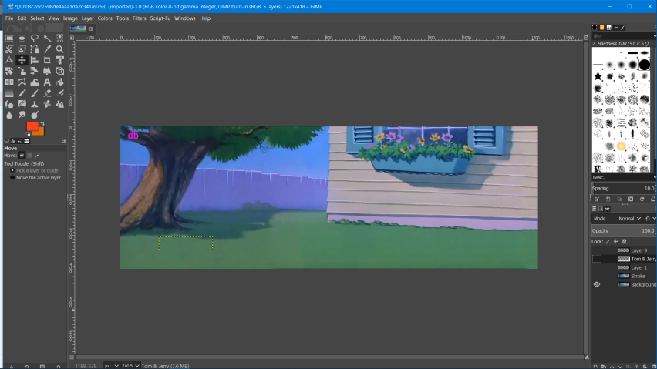

3. Now select the path tool ,draw the Tom character over it and stroke it with the line colour as solid and assigning a particular line style.

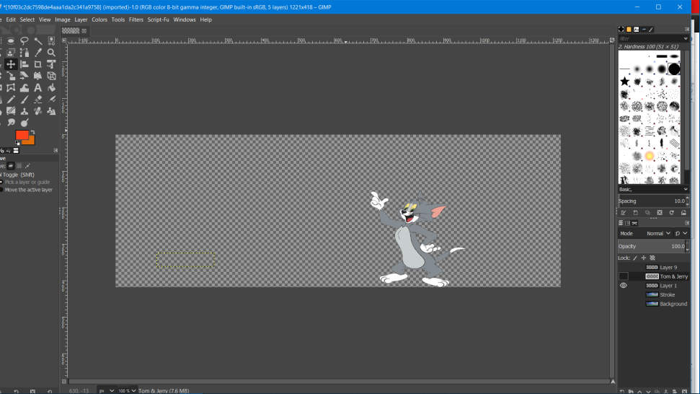

4. Now again select the stroke path tool and trace the outer area of the jeery’s character . After tracing the outer area of the character and then click on the stroke to path selection

5. After that trace the inner body of the character and face then click on the stroke to path selection.

5. With the help of the bucket fill tool, fill different areas of the character with desired colour.

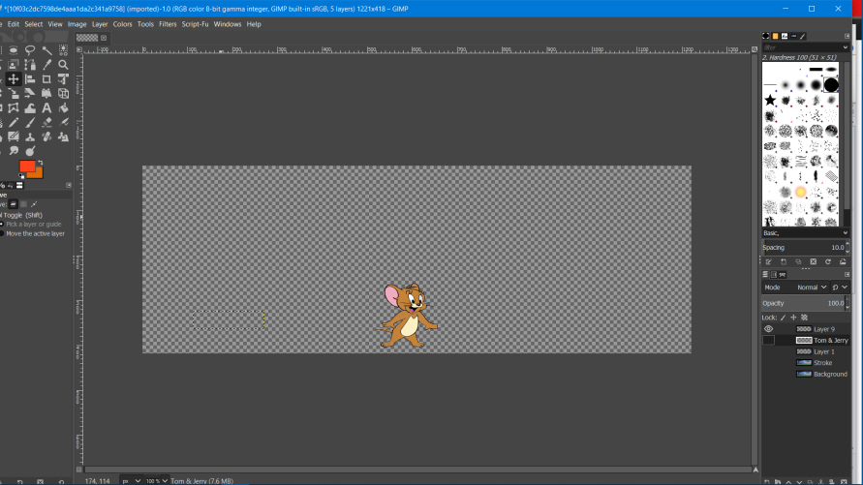

6. Now add the text “Tom & Jerry” to it with the help of the text tool. Assign a particular size and select the desired colour by using the font “Brush Script MT”

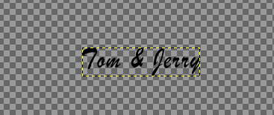

7. When Done, Save the file with the extension .xcf and assign a particular name to it.

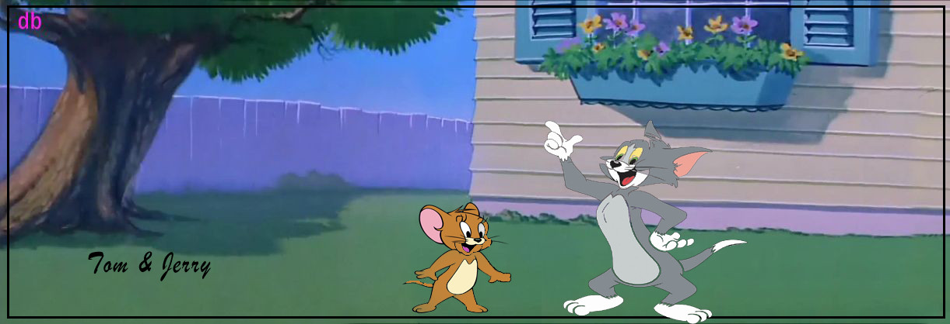

**Typography**

Font name – Brush Script Mt

Kerning – 220 pt

Tracking – 120%

Font width – 100%

Leading – 0.00